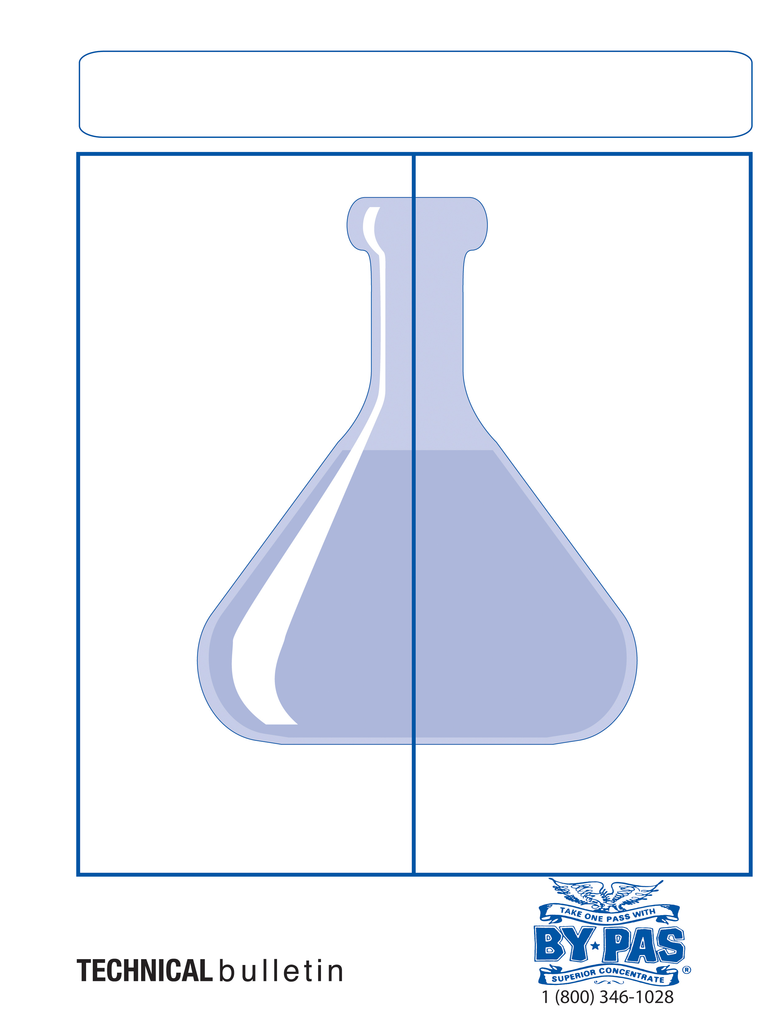
DESCRIPTION:

Delivers that “caustic” punch needed for those tough jobs! High foaming for vertical cling; quickly breaks down stubborn baked on soils, carbon, thick grease/oils, fats/proteins, bio-film and more from ovens, walls, floors, fryers, grease traps, hood fans, equipment, appliances and more!

CONTAINER AVAILABILITY:

5-gallon Pail, 55 Gallon Drum

PHYSICAL PROPERTIES:

Physical Form | Aqueous
Color | Dark Amber
Odor | Detergent / Amine
Solubility in Water | Complete
VOC’s: | 0%
Specific Gravity: | 1.32-1.36
pH of concentrate | 13.8

PRODUCT CAUTIONS: CORROSIVE
Contains: Sodium Hydroxide! Wear eye protection, chemical proof body suit/apron and protective gloves when handling. Do not breathe strong product vapors. Adequate ventilation is needed when using at high concentrations. Keep lids sealed when not in use. Rinse thoroughly with water, do not allow product to dry. Do not use concentrations over 10% on aluminum if soaking. Refer to the MSDS for further safety information.

ADVANTAGES:

High alkalinity loosens the toughest buildups found in restaurants, food processing plants, industrial plants.

Breaks down thick grease, oils and fats from many hard surfaces fast and effectively!

Biodegradable; contains NO: Phosphates or phenols, VOC free and safe on food contact surfaces!

High foam, excellent detergency, fast rinsing!

Inhibitor protects against corrosion on metals!

APPLICATIONS:

C.I.P system, foamers, low or high pressure spray, mob bucket!

DILUTION RATIO’S:

Heavy Cleaning: 25-50% product in water
Medium Cleaning: 5-20% product in water
General Cleaning: 1-4% product in water

**Rinse food contact surfaces with potable water after use. Do not allow to dry!

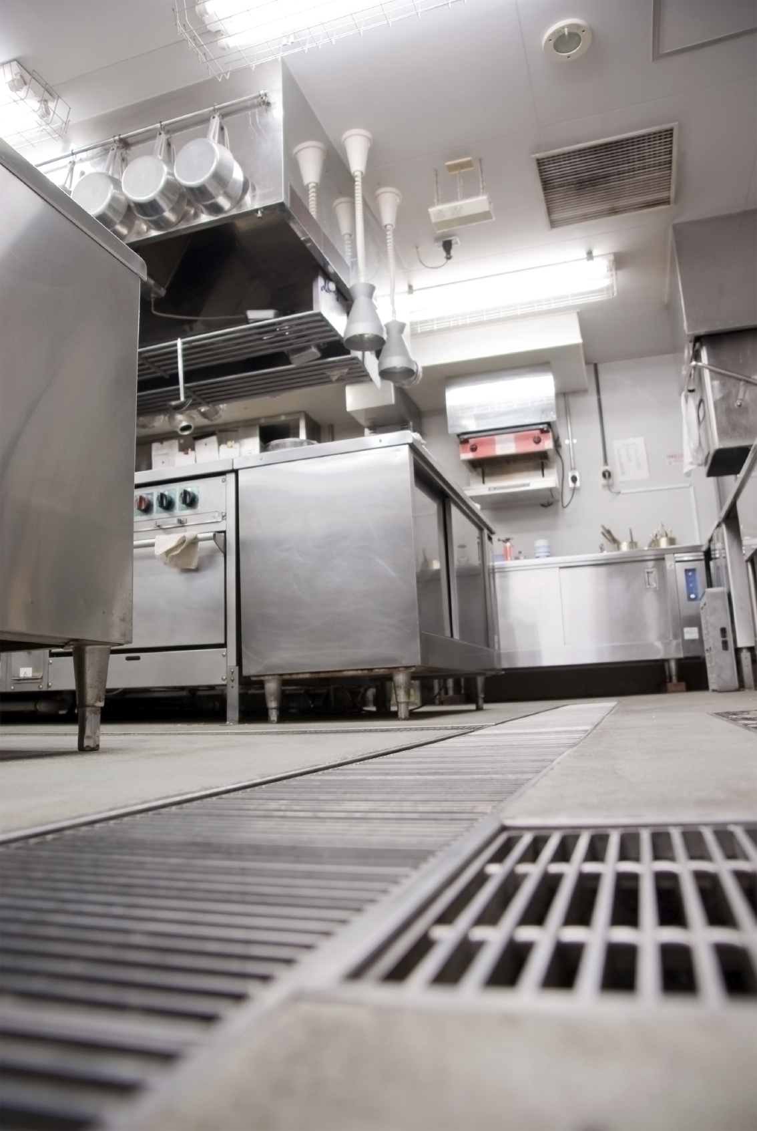

BY*PAS DGR-2030CF

HIGH ALKALINE FOAMING C.I.P DETERGENT

